Activity 3.4.1: Pedigree Resource Sheet

Introduction
Pedigrees are graphic organizers that show how a particular gene is passed down from one generation to the next. Symbols are used to represent each individual. Males are represented by squares, while females are represented by circles. Relationships are represented with lines. Pedigree diagrams make it easy to visualize relationships within families and are used to determine the mode of inheritance (dominant versus recessive) of genetic diseases.

The symbols below are used to create a pedigree. If a person expresses a gene, that person is considered to be affected by the trait and is represented with circles and squares that are filled in. If the trait is not expressed, then that person is considered to be unaffected and is represented with circles and squares that are not filled in. Carriers for a trait are sometimes represented with circles and squares that are only half filled in.

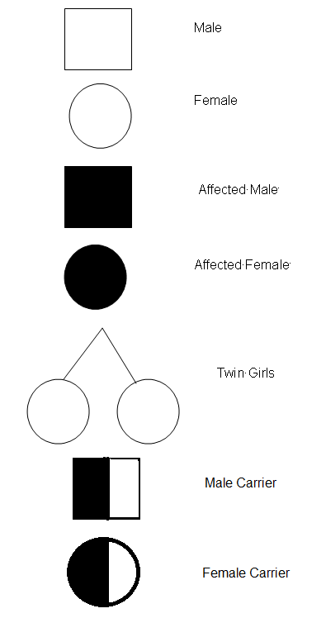

Each row of the pedigree diagram indicates one generation, and the connecting lines indicate a direct relationship between individuals. The generations are listed using Roman numerals. The individuals within each generation are indicated by Arabic numerals. The order of birth within a generation is indicated by placing the first born at the far left and progressing from left to right with each subsequent child.

The pedigree below indicates a man and a woman in generation I who had three sons and who are the grandparents of twin girls. The oldest son showed the trait, but his two younger brothers did not. The youngest son had twin daughters. The oldest son is referred to as individual II-1, for generation two, first born. His mother would be referred to as I-2, for generation one, second individual. His nieces would be III-1 and III-2, for generation three, first and second individuals, respectively.

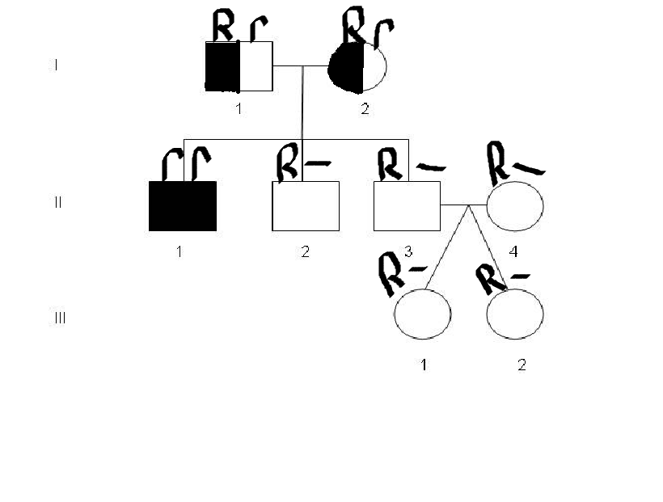
Check for Understanding:
- Did either of the twin daughters, III-1 or III-2, show the trait?
The twin daughters don’t show the trait because they are shaded in white.
Inheritance
If more than one individual in a family is afflicted with a disease, it is a clue that the disease may be inherited. A doctor needs to look at family history to determine whether the disease is indeed inherited and, if it is, to establish the mode of inheritance. This information can then be used to predict risk in future generations. A basic method for determining the pattern of inheritance of any trait is to look at its occurrence in several individuals within a family, spanning as many generations as possible. For a disease trait, a doctor has to examine existing family members to determine who is affected and who is not.

The information presented in a pedigree can be analyzed to determine whether a given physical trait is inherited or not and what the pattern of inheritance is (whether a trait is dominant or recessive). A dominant trait is passed on to a son or daughter from only one parent. Characteristics of a dominant pedigree are:
- Every affected individual has at least one affected parent
- Affected individuals who mate with unaffected individuals have a 50% chance of transmitting the trait to each child
- Two affected individuals may have unaffected children

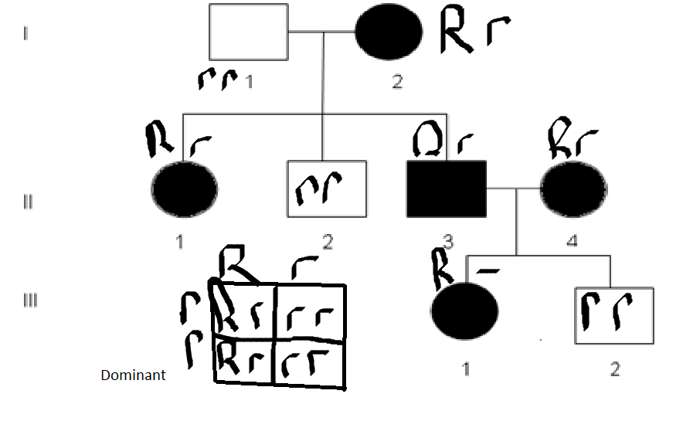
Check for Understanding:
- Would it be possible for individual II-4 to have two unaffected parents?
No it wouldn’t be possible because the disease is dominant

- If individual III-1 mates with an unaffected individual, what is the percent chance of transmitting the trait to their child?
If she is heterozougous then their child will have a 50/50 chance of gaining the trait.

Recessive traits are passed on to children from both parents, although the parents may seem perfectly "normal." Characteristics of recessive pedigrees are:
- An individual who is affected may have parents who are not affected
- All children of two affected individuals are affected

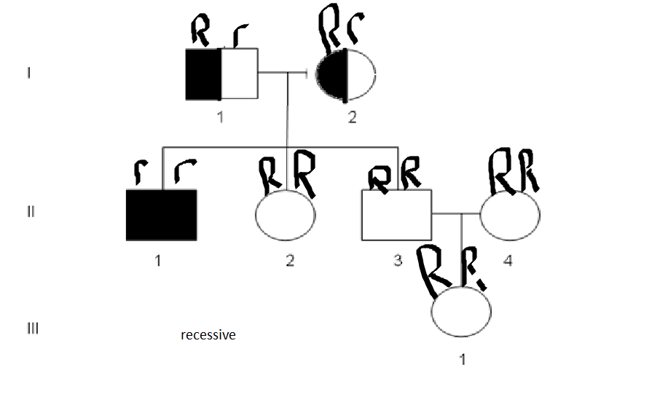
Check for Understanding:
- Individuals I-1 and I-2 are said to be __carriers___________.

- If individual II-1 mates with an affected individual, what is the percent chance that their offspring will be affected? 75%

